The UX of Health Insurance: Part 2 Heuristic Review

The state of South African Medical Aid Websites in 2020

This is Part 2 in a series of 4, where we explore the usability and patient experience across the websites of the most popular Medical Aid companies in South Africa. You can find Part 1 here.

If you’re in a rush…
- Our team of design experts assessed 17 healthcare provider’s websites against a set of usability standards found in The Sand Dollar Design Heuristic Framework.
- We found that:
  - Many websites can improve their homepage, navigation and search functionality through improvements in structure, visibility and accessibility.
  - Many health insurance providers overwhelm users by filling their websites with promotional content and can improve by deciding on a user-centred content strategy and by displaying content in an accessible way.
  - Many websites can improve the user experience of their websites by making improvements to basic interactivity such as form input, error handling and help.

Introduction
In Part 2 of our series on the state of South African Medical Aid Websites in 2020, we will be sharing our insights from the Heuristic Review we conducted.

A Heuristic Review is when a team of user experience design experts examine a user interface. These designers are looking for issues by checking the design against a set of usability standards (“heuristics”), and drawing on their experience in user interface design. A Heuristic Review is a key part of the Sand Dollar Design Heuristic Framework.

Our designers assess:
- The features and functionality available to users to see whether these features help users achieve their goals.
- User interface elements such as the homepage, navigation and search functionality in terms of structure, visibility and accessibility.
- Content and text in terms of legibility and relevancy.
- System feedback, error handling and user help in terms of availability, ease of recovery, accessibility and usefulness.
- Forms in terms of structure and ease of use; and finally
- The software performance of the interface.

Who did we evaluate?
Our team of researchers evaluated the websites of (alphabetical):
Affinity Health, Bestmed, Bonitas, Discovery Health, Fedhealth, GEMS, Genesis, Lenmed, Medihelp, Medshield, Momentum, Polmed, Profmed, Selfmed, Umvuzo, United Healthcare and Vitality.
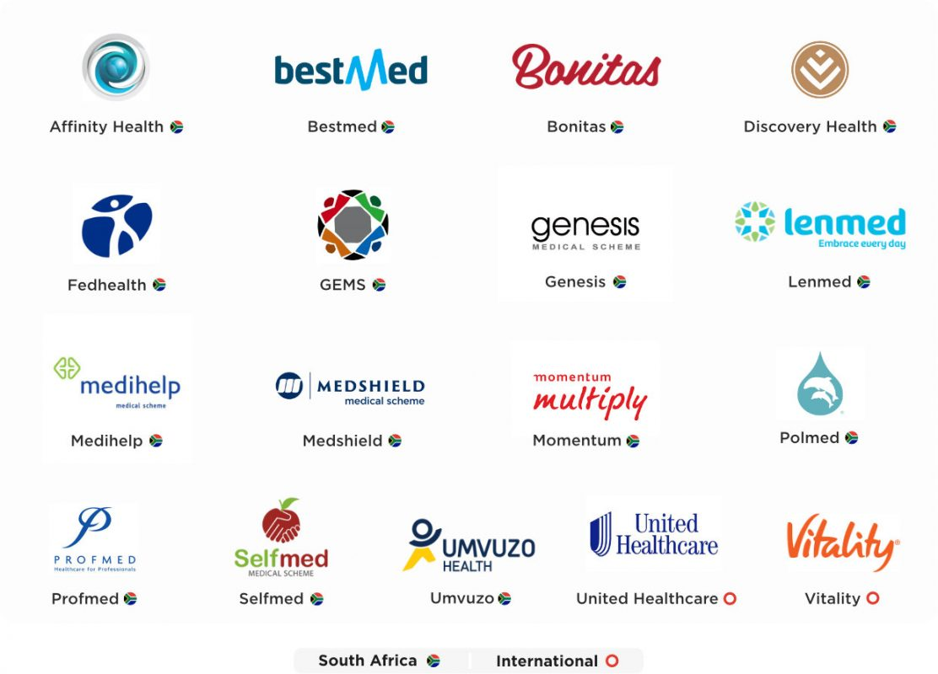

What are our key insights?

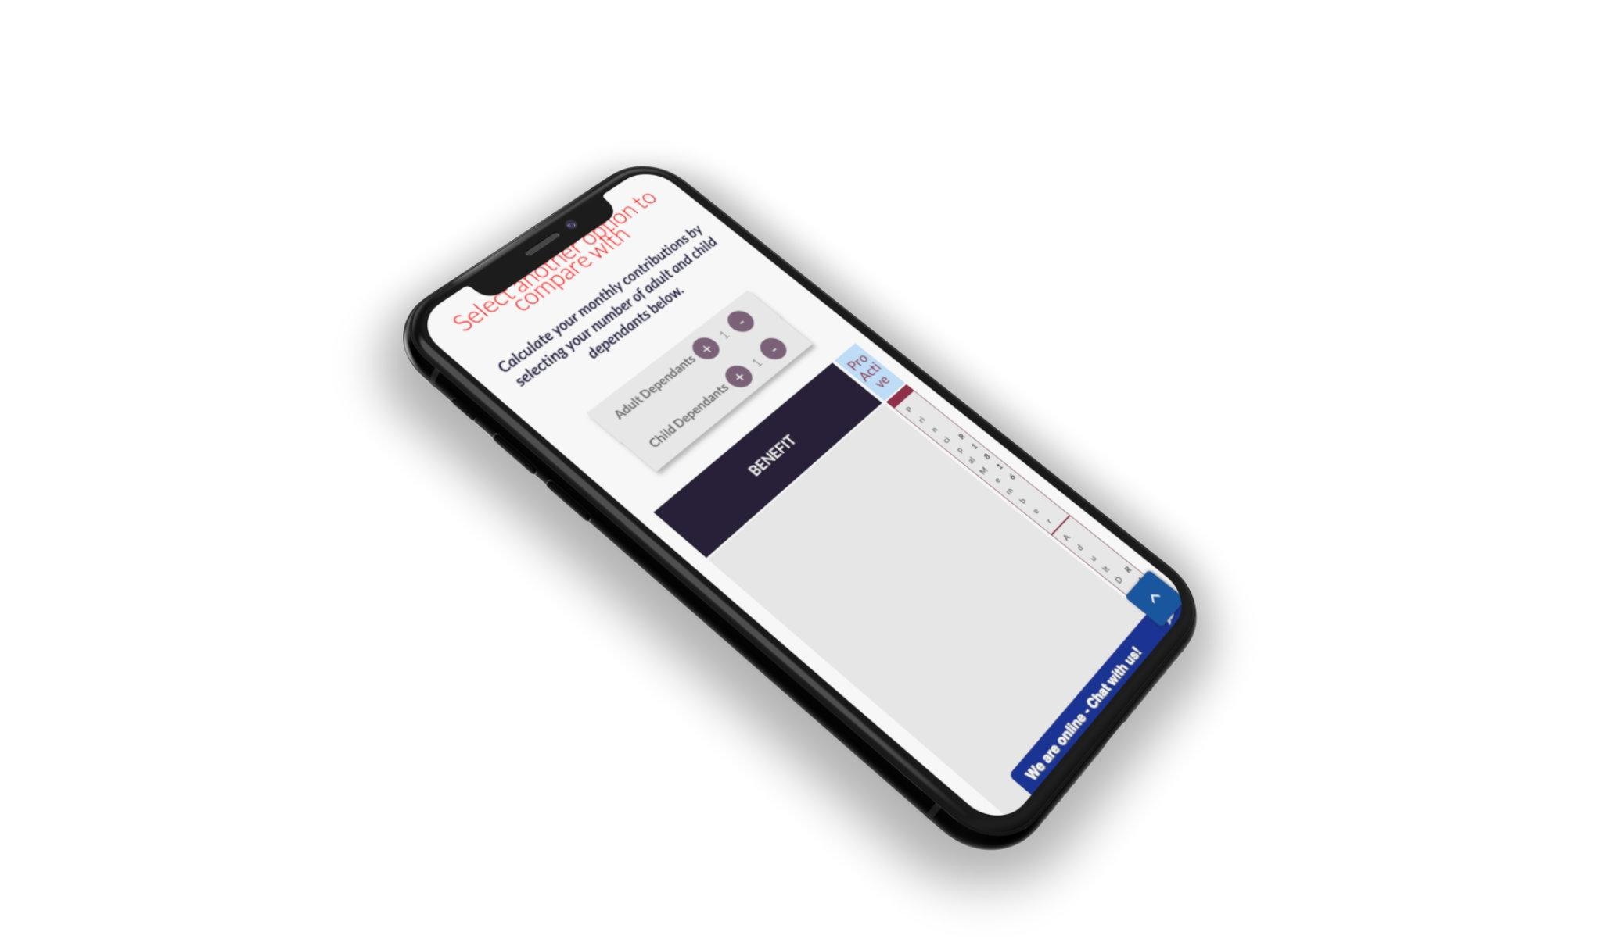

Layout
We noticed that the layout of many healthcare provider’s website’s are difficult to navigate, especially homepages, search and navigation.

People visiting a health insurance website will often be in a rush, perhaps feeling anxious and overwhelmed due to medical or financial circumstances. These websites should therefore be quick and easy to use.

Every page that a user opens should be easy to understand. This is especially true of homepages which should provide an overview of the most important information and tasks found throughout a website. For example, most users would expect to be able to view and compare medical aid plans or get a quote from the home page, however this is typically not found on most providers websites.

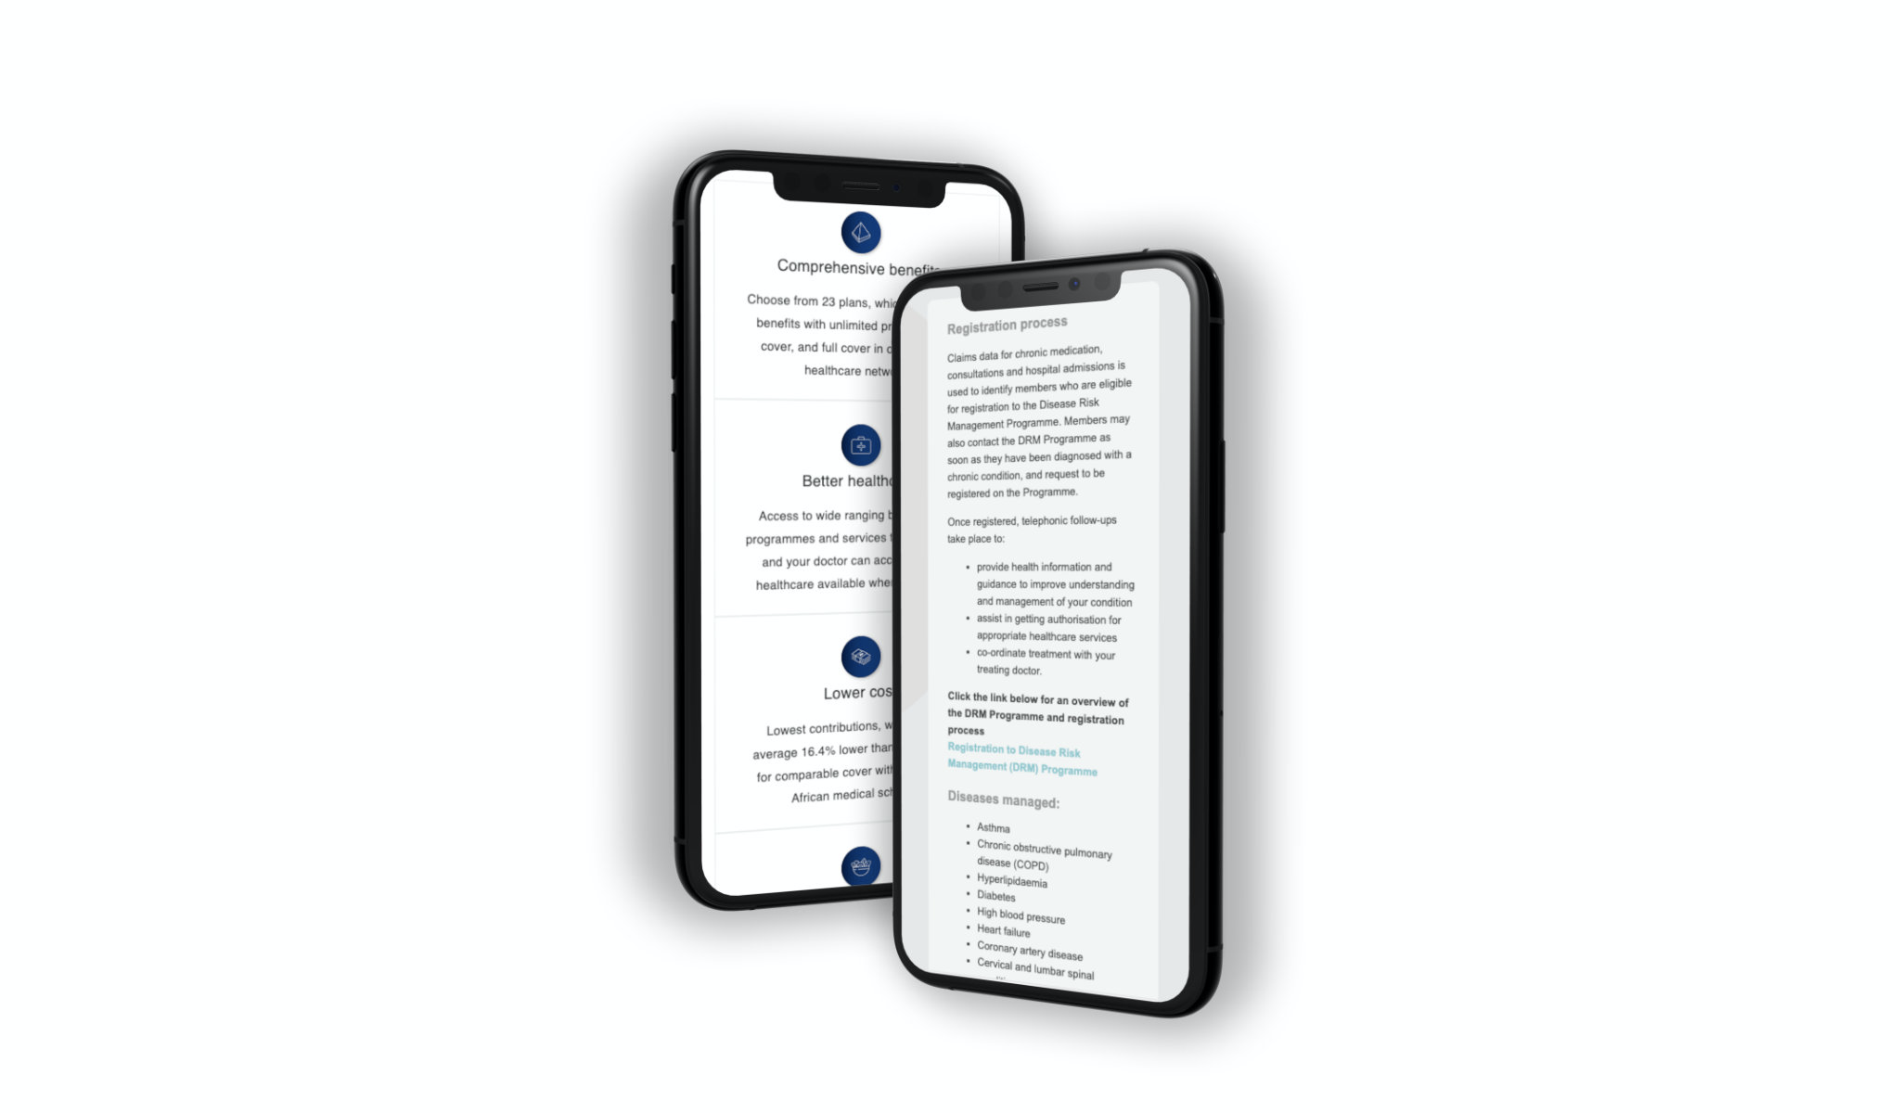

Content
Many healthcare insurance providers’ overwhelm users by filling their websites with promotional content, lifestyle blogs and lengthy paragraphs of noncritical information. People will often skim or become overwhelmed by these large clusters of information and often leave the website before finding what they came looking for in the first place. This is especially true for people who speak English as a second or third language.

Some providers are doing well by condensing information, such as medical aid plan details into short and informative videos or well structured pages, however there are many others who still need to decide on a user-centred content strategy and on displaying content in an accessible way.

Less content affords more value, and by displaying only the most important information with a clear use of hierarchy and plain language, providers can easily improve the usability of their websites. Additionally, it is critical to identify the key tasks that any target users may want to complete on a website (e.g. compare plans, get a quote, find a doctor etc.) and it is important to prioritise these things in both the structure and the content of the website.

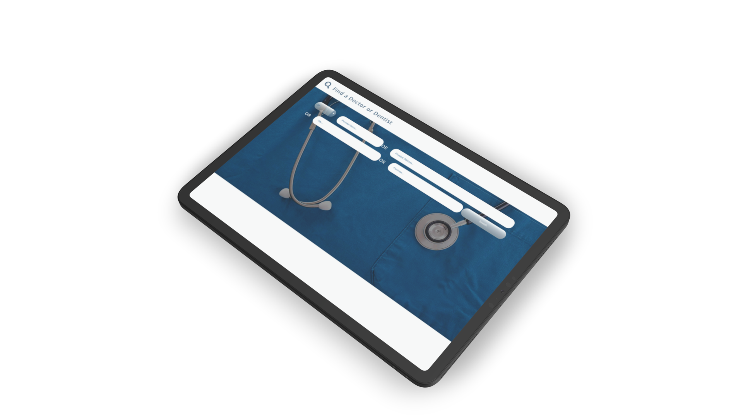

Interactivity
Many health insurance providers can improve the user experience of their websites by making improvements to basic interactivity. System feedback, error handling and user help, as well as form handling and website performance are the foundation of a great website, however these are often overlooked.

The following are areas which we identified providers could improve in:
- Complex forms and processes should be broken up into readily understood steps and sections.
- Form input should be checked and verified before being processed.
- Confirmation messages should follow successful transactions and it should be made clear to users when a page has been updated.
- Errors should be immediately apparent to users and should be highlighted, together with an explanation for the error.
- Help should be written in easy to understand language.
- Users should easily be able find help and where appropriate contextual help should be available, such as help for a specific page, feature or process.

In summary
During the Heuristic review phase of our evaluation of South African and international health insurance websites we identified various improvements that could be made in the layout, content and interactivity of Health Insurance websites. By applying some of the basic principles of User Experience Design, these organisations could vastly improve the experience of their potential and current clients/members and most likely improve their business outcomes.

Keep an eye out for the next installment of The UX of Health Insurance 2020 research series with Part 3: Cognitive Walkthrough coming soon.

Find out more
If you are interested in more detailed insights from this study, request a detailed report on our findings.

About Sand Dollar Design
Sand Dollar Design is a Product Innovation and Experience Design Consulting firm, with a passion for re-imagining the Patient and Provider experience through Digital Health interventions, in order to achieve improved Healthcare outcomes for all.
Find out more about our services at www.sanddollardesign.co.za

